รายงานการตรวจประเมิน
(Feedback Report)

คณะวิทยาศาสตร์และเทคโนโลยี
มหาวิทยาลัยนราธิวาสราชนครินทร์

วัน/เดือน/ปี

โดยใช้เกณฑ์คุณภาพการศึกษาเพื่อการดำเนินการที่เป็นเลิศ
Education Criteria for Performance Excellence (EdPEx)
ประจำปีการศึกษา ………..
สารบัญ

เรื่อง หน้า

วัตถุประสงค์ แนวทาง และคณะกรรมการตรวจประเมิน
ปัจจัยที่มีความสำคัญ (Key Factors)
รายละเอียดผลการตรวจประเมินแยกรายหมวดและหัวข้อ
หมวด 1 การนำองค์กร
หมวด 2 กลยุทธ์
หมวด 3 ลูกค้า
หมวด 4 การวัด การวิเคราะห์ และการจัดการความรู้
หมวด 5 บุคลากร
หมวด 6 การปฏิบัติการ
หมวด 7 ผลลัพธ์
ตารางสรุปผลการประเมิน (Band Number)

วัตถุประสงค์ แนวทาง และคณะกรรมการตรวจประเมิน

วัตถุประสงค์
............................................................................................................................................................................................................................................................................................................................................................................................................................................................................................................................

แนวทางที่ใช้ในการตรวจประเมิน
............................................................................................................................................................................................................................................................................................................................................................................................................................................................................................................................

รายนามคณะกรรมการตรวจประเมิน
- ……………………. ประธานกรรมการ
- …………………… กรรมการ
- ………………….. กรรมการ

บทสรุปและผลการตรวจประเมินในภาพรวม (Key Theme)

ก. Process Strength

ข. Process OFI

ค. Result Strength

ง. Result OFI

รายละเอียดผลการตรวจประเมินแยกรายหมวดและหัวข้อ

หมวด 1 การนำองค์กร

1.1 การนำองค์กรโดยผู้นำระดับสูง Overall score = 20 %

Strength
............................................................................................................................................................................................................................................................................................................................................................................................................................................................................................................................
OFI
............................................................................................................................................................................................................................................................................................................................................................................................................................................................................................................................

1.2 การกำกับดูแลองค์กรและการสร้างประโยชน์ให้สังคม Overall score = 15 %

Strength
............................................................................................................................................................................................................................................................................................................................................................................................................................................................................................................................

OFI
............................................................................................................................................................................................................................................................................................................................................................................................................................................................................................................................

หมวด 2 กลยุทธ์

2.1 การจัดทำกลยุทธ์ Overall score = 15 %

Strength
............................................................................................................................................................................................................................................................................................................................................................................................................................................................................................................................

OFI
............................................................................................................................................................................................................................................................................................................................................................................................................................................................................................................................

2.2 การนำกลยุทธ์ไปปฏิบัติ Overall score = 10 %
Strength
............................................................................................................................................................................................................................................................................................................................................................................................................................................................................................................................

OFI
............................................................................................................................................................................................................................................................................................................................................................................................................................................................................................................................

หมวด 3 ลูกค้า
3.1 ความคาดหวังของลูกค้า Overall score = 15 %
Strengths
............................................................................................................................................................................................................................................................................................................................................................................................................................................................................................................................
OFI
............................................................................................................................................................................................................................................................................................................................................................................................................................................................................................................................

3.2 ความผูกพันของลูกค้า Overall score = 15 %
Strengths
............................................................................................................................................................................................................................................................................................................................................................................................................................................................................................................................
OFI
............................................................................................................................................................................................................................................................................................................................................................................................................................................................................................................................

หมวด 4 การวัด การวิเคราะห์ และการจัดการความรู้

4.1 การวัด การวิเคราะห์ และการปรับปรุงผลการดำเนินการของสถาบัน Overall score = 15%

Strength
............................................................................................................................................................................................................................................................................................................................................................................................................................................................................................................................

OFI
............................................................................................................................................................................................................................................................................................................................................................................................................................................................................................................................

4.2 การจัดการสารสนเทศ และการจัดการความรู้ Overall score = 10%

Strength
............................................................................................................................................................................................................................................................................................................................................................................................................................................................................................................................

OFI
............................................................................................................................................................................................................................................................................................................................................................................................................................................................................................................................

หมวด 5 บุคลากร

5.1 สภาวะแวดล้อมด้านบุคลากร Overall score = 20%

Strength
............................................................................................................................................................................................................................................................................................................................................................................................................................................................................................................................

OFI
...........................................................................................................................................................................................................................................................................................................................................................................................................................................................................................................................

5.2 ความผูกพันของบุคลากร Overall score = 15%

Strength
............................................................................................................................................................................................................................................................................................................................................................................................................................................................................................................................

OFI
............................................................................................................................................................................................................................................................................................................................................................................................................................................................................................................................

หมวด 6 การปฏิบัติการ

6.1 กระบวนการทำงาน Overall score = 10%

Strength
............................................................................................................................................................................................................................................................................................................................................................................................................................................................................................................................
OFI
............................................................................................................................................................................................................................................................................................................................................................................................................................................................................................................................

6.2 ประสิทธิผลของกระบวนการ Overall score =10%

Strength

............................................................................................................................................................................................................................................................................................................................................................................................................................................................................................................................

OFI
............................................................................................................................................................................................................................................................................................................................................................................................................................................................................................................................

หมวด 7 ผลลัพธ์

7.1 ผลลัพธ์ด้านการเรียนรู้ของผู้เรียน และด้านกระบวนการ Overall score = 20 %

Strength
............................................................................................................................................................................................................................................................................................................................................................................................................................................................................................................................

OFI ............................................................................................................................................................................................................................................................................................................................................................................................................................................................................................................................

7.2 ผลลัพธ์ด้านลูกค้า Overall score = 15%

Strength
............................................................................................................................................................................................................................................................................................................................................................................................................................................................................................................................
OFI
............................................................................................................................................................................................................................................................................................................................................................................................................................................................................................................................

7.3 ผลลัพธ์ด้านบุคลากร Overall score = 10 %

Strength
............................................................................................................................................................................................................................................................................................................................................................................................................................................................................................................................

OFI
............................................................................................................................................................................................................................................................................................................................................................................................................................................................................................................................

7.4 ผลลัพธ์ด้านการนำองค์กรและการกำกับดูแลองค์กร Overall score = 15 %

Strength
............................................................................................................................................................................................................................................................................................................................................................................................................................................................................................................................

OFI
............................................................................................................................................................................................................................................................................................................................................................................................................................................................................................................................

7.5 ผลลัพธ์ด้านงบประมาณ การเงิน ตลาด และกลยุทธ์ Overall score = 15 %

Strength ............................................................................................................................................................................................................................................................................................................................................................................................................................................................................................................................

OFI
............................................................................................................................................................................................................................................................................................................................................................................................................................................................................................................................
6. ตารางสรุปผลการประเมิน (Band Number)

- ระดับการประเมินในภาพรวมด้านกระบวนการ (Process Scoring Band) = Band 1
- ระดับการประเมินในภาพรวมด้านผลลัพธ์ (Result Scoring Band) = Band 1

หมายเหตุ : ระดับการประเมินในภาพรวม (Band Number) เป็นการรวมคะแนนผลการประเมินจากทุกหัวข้อตามเกณฑ์ EdPEx ทั้ง 17 ข้อ แล้วจึงทำการแปลผลออกมาเป็นระดับการประเมินในภาพรวม ไม่ได้เป็นการนำระดับการประเมินรายหัวข้อ (Item Band) มาเฉลี่ยรวมกันแต่อย่างใด

หมวด | หัวข้อ | คะแนนเต็ม | % ที่ได้ | คะแนนที่ได้
1 การนำองค์การ | 1.1 การนำองค์กรโดยผู้นำระดับสูง | 65
1 การนำองค์การ | 1.2 การกำกับดูแลองค์กรและการสร้างประโยชน์ให้สังคม | 50
1 การนำองค์การ | ผลคะแนนรวม | 115
2 กลยุทธ์ | 2.1 การจัดทำกลยุทธ์ | 45
2 กลยุทธ์ | 2.2 การนำกลยุทธ์ไปปฏิบัติ | 45
2 กลยุทธ์ | ผลคะแนนรวม | 90
3 ลูกค้า | 3.1 ความคาดหวังของลูกค้า | 40
3 ลูกค้า | 3.2 ความผูกพันของลูกค้า | 45
3 ลูกค้า | ผลคะแนนรวม | 85
4 การวัด การวิเคราะห์และการจัดการความรู้ | 4.1 การวัด วิเคราะห์ และปรับปรุงผลการดำเนินการของสถาบัน | 45
4 การวัด การวิเคราะห์และการจัดการความรู้ | 4.2 การจัดการสารสนเทศ และการจัดการความรู้ | 45
4 การวัด การวิเคราะห์และการจัดการความรู้ | ผลคะแนนรวม | 90
5 บุคลากร | 5.1 สภาวะแวดล้อมด้านบุคลากร | 40
5 บุคลากร | 5.2 ความผูกพันของบุคลากร | 45
5 บุคลากร | ผลคะแนนรวม | 85
6 ระบบปฏิบัติการ | 6.1 กระบวนการทำงาน | 40
6 ระบบปฏิบัติการ | 6.2 ประสิทธิผลของการปฏิบัติการ | 45
6 ระบบปฏิบัติการ | ผลคะแนนรวม | 85
6 ระบบปฏิบัติการ | คะแนนรวม หมวด 1-6 | 550
หมวด 7 ผลลัพธ์ | 7.1 ผลลัพธ์ด้านการเรียนรู้ของผู้เรียน และบริการที่ตอบสนองต่อลูกค้ากลุ่มอื่น และด้านกระบวนการ | 120
หมวด 7 ผลลัพธ์ | 7.2 ผลลัพธ์ด้านลูกค้า | 80
หมวด 7 ผลลัพธ์ | 7.3 ผลลัพธ์ด้านบุคลากร | 80
หมวด 7 ผลลัพธ์ | 7.4 ผลลัพธ์ด้านการนำองค์กรและการกำกับดูแลองค์กร | 80
หมวด 7 ผลลัพธ์ | 7.5 ผลลัพธ์ด้านงบประมาณ การเงิน ตลาด และกลยุทธ์ | 90
หมวด 7 ผลลัพธ์ | ผลคะแนนรวม หมวด 7 | 450
รวมทั้งสิ้น |  | 1,000

คำอธิบายการแปลผลระดับการประเมินรายหมวด (Item Band) ดังตาราง 1-2 และคำอธิบายการแปลผลระดับการประเมินในภาพรวม (Overall Band) ดังตาราง 3-4 มีรายละเอียดดังนี้

ตาราง 1 แนวทางการให้คะแนนรายหมวด สำหรับหมวด 1-6 (Item Band)
คะแนน | คำอธิบาย
0% หรือ5%  (Band 1) | A: ไม่มีแนวทางอย่างเป็นระบบให้เห็น มีสารสนเทศเพียงผิวเผิน  D: ไม่มีการนำแนวทางที่เป็นระบบไปถ่ายทอดเพื่อนำไปปฏิบัติ หรือมีเพียงเล็กน้อย  L: ไม่แสดงให้เห็นว่ามีแนวคิดในการปรับปรุง มีการปรับปรุงเมื่อเกิดปัญหา  I : ไม่แสดงให้เห็นว่ามีความสอดคล้องไปในแนวทางเดียวกันในระดับสถาบัน แต่ละส่วนหรือหน่วยงานดำเนินการอย่างเอกเทศ
10%,15%, 20% หรือ25%  (Band 2) | A: แสดงให้เห็นว่าเริ่มมีแนวทางที่เป็นระบบที่ตอบสนองต่อข้อกำหนดพื้นฐานของหัวข้อ  D: การนำแนวทางไปถ่ายทอดเพื่อนำไปปฏิบัติเพียงอยู่ในขั้นเริ่มต้นในเกือบทุกส่วนหรือหน่วยงานซึ่งเป็นอุปสรรคต่อการบรรลุข้อกำหนดพื้นฐานของหัวข้อนั้น  L: แสดงให้เห็นว่าเริ่มมีการเปลี่ยนแปลงจากการตั้งรับปัญหามาเป็นแนวคิดในการปรับปรุงแบบพื้นๆ  I : มีแนวทางที่สอดคล้องไปในแนวทางเดียวกันกับส่วนหรือหน่วยงานอื่น โดยส่วนใหญ่เกิดจากการร่วมกันแก้ปัญหา
30%, 35%, 40%หรือ 45%  (Band 3) | A: แสดงให้เห็นว่ามีแนวทางที่เป็นระบบและมีประสิทธิผลที่ตอบสนองต่อข้อกำหนดพื้นฐานของหัวข้อ  D: มีการนำแนวทางไปถ่ายทอดเพื่อนำไปปฏิบัติ ถึงแม้ว่าบางส่วนหรือบางหน่วยงานเพิ่งอยู่ในขั้นเริ่มต้น  L: แสดงให้เห็นว่าเริ่มมีแนวทางอย่างเป็นระบบในการประเมินและปรับปรุงกระบวนการที่สำคัญ  I : แนวทางเริ่มมีความสอดคล้องกับความต้องการพื้นฐานของสถาบัน ตามที่ระบุไว้ในโครงร่างองค์การและเกณฑ์หมวดอื่น ๆ
50%,55%, 60% หรือ 65%  (Band 4) | A: แสดงให้เห็นว่ามีแนวทางที่เป็นระบบและมีประสิทธิผลที่ตอบสนองต่อข้อกำหนดโดยรวมของหัวข้อ  D: มีการนำแนวทางไปถ่ายทอดเพื่อนำไปปฏิบัติเป็นอย่างดี ถึงแม้การปฏิบัติอาจแตกต่างกันในบางส่วนหรือบางหน่วยงาน  L: มีกระบวนการประเมินและปรับปรุงอย่างเป็นระบบโดยใช้ข้อมูลจริง และเริ่มมีการเรียนรู้ในระดับองค์การ ซึ่งรวมถึงการสร้างนวัตกรรมเพื่อปรับปรุงประสิทธิภาพและประสิทธิผลของกระบวนการที่สำคัญ  I:แนวทางมีความสอดคล้องกับความต้องการโดยรวมของสถาบัน ตามที่ระบุไว้ในโครงร่างองค์การ  และเกณฑ์หมวดอื่น ๆ
70%,75%, 80% หรือ 85%  (Band 5) | A: แสดงให้เห็นว่ามีแนวทางที่เป็นระบบและมีประสิทธิผลที่ตอบสนองต่อข้อกำหนดโดยรวมของหัวข้อ  D: มีการนำแนวทางไปถ่ายทอดเพื่อไปปฏิบัติเป็นอย่างดีโดยไม่มีความแตกต่างของการปฏิบัติอย่างมีนัยสำคัญ  L: มีกระบวนการประเมินและปรับปรุงอย่างเป็นระบบโดยใช้ข้อมูลจริง และเริ่มมีการเรียนรู้ในระดับองค์การ ซึ่งรวมถึงการสร้างนวัตกรรม เป็นเครื่องมือสำคัญในการจัดการ มีหลักฐานชัดเจนของการพัฒนาอันเป็นผลเนื่องมาจากการวิเคราะห์และการเรียนรู้ระดับองค์การ  I : แนวทางมีบูรณาการกับความต้องการของสถาบัน ทั้งในปัจจุบันและอนาคต ตามที่ระบุไว้ในโครงร่างองค์การและเกณฑ์หมวดอื่น ๆ
90%, 95%  หรือ 100%  (Band 6) | A: แสดงให้เห็นว่ามีแนวทางที่เป็นระบบและมีประสิทธิผลที่ตอบสนองต่อข้อกำหนดโดยรวมของหัวข้ออย่างสมบูรณ์  D: มีการนำแนวทางไปถ่ายทอดเพื่อนำไปปฏิบัติอย่างสมบูรณ์โดยไม่มีจุดอ่อนหรือความแตกต่างที่สำคัญระหว่างส่วนหรือหน่วยงาน  L: มีกระบวนการประเมินและปรับปรุงอย่างเป็นระบบโดยใช้ข้อมูลจริงและมีการเรียนรู้ในระดับองค์การผ่านการสร้างนวัตกรรม เป็นเครื่องมือสำคัญที่ใช้ทั่วทั้งองค์การในการจัดการ มีหลักฐานชัดเจนของการพัฒนาและนวัตกรรมทั่วทั้งองค์การ อันเป็นผลเนื่องมาจากการวิเคราะห์และแบ่งปัน  I : แนวทางมีบูรณาการอย่างสมบูรณ์กับความต้องการของสถาบันทั้งในปัจจุบันและอนาคตตามที่ระบุไว้ในโครงร่างองค์การและเกณฑ์หมวดอื่น ๆ

ตาราง 2 แนวทางการให้คะแนนรายหมวด สำหรับหมวด 7 (Item Band)

คะแนน | คำอธิบาย
0% หรือ5%  (Band 1) | Le: ไม่มีการรายงานผลการดำเนินการของสถาบัน และ/ หรือมีผลลัพธ์ที่ไม่ดีในเรื่องที่รายงานไว้  T: ไม่มีการรายงานข้อมูลที่แสดงแนวโน้ม หรือมีข้อมูลที่แสดงแนวโน้มในทางลบ  C: ไม่มีการรายงานสารสนเทศเชิงเปรียบเทียบ  I : ไม่มีการรายงานผลลัพธ์ในเรื่องที่มีความสำคัญต่อการบรรลุพันธกิจของสถาบัน
10%,15%, 20% หรือ25%  (Band 2) | Le: มีการรายงานผลการดำเนินการของสถาบันเพียงบางเรื่องที่สำคัญต่อสถาบัน ตามที่ระบุไว้ในข้อกำหนดของหัวข้อ และเริ่มมีระดับผลการดำเนินการที่ดีในบางเรื่อง  T: มีการรายงานแนวโน้มของข้อมูลบางเรื่อง บางเรื่องแสดงแนวโน้มในทางลบ  C: แทบไม่มี หรือไม่มีการรายงานสารสนเทศเชิงเปรียบเทียบ  I : มีการรายงานผลลัพธ์เพียงบางเรื่องที่มีความสำคัญต่อการบรรลุพันธกิจของสถาบัน
30%, 35%, 40%หรือ 45%  (Band 3) | Le: มีการรายงานถึงระดับผลการดำเนินการที่ดีในบางเรื่องที่สำคัญต่อสถาบันตามที่ระบุไว้  ในข้อกำหนดของหัวข้อ  T: มีการรายงานแนวโน้มของข้อมูลบางเรื่อง และข้อมูลส่วนใหญ่ที่แสดงนั้นมีแนวโน้มที่ดี  C: เริ่มมีสารสนเทศเชิงเปรียบเทียบ  I : มีการรายงานผลลัพธ์ในหลายเรื่องที่มีความสำคัญต่อการบรรลุพันธกิจของสถาบัน
50%,55%, 60% หรือ 65%  (Band 4) | Le: มีการรายงานถึงระดับผลการดำเนินการที่ดีในเกือบทุกเรื่องที่มีความสำคัญต่อสถาบัน  ตามที่ระบุไว้ในข้อกำหนดของหัวข้อ  T: แสดงถึงแนวโน้มที่ดีอย่างชัดเจนในเรื่องต่าง ๆ ที่มีความสำคัญต่อการบรรลุพันธกิจของสถาบัน  C: ผลการดำเนินการในปัจจุบันในบางเรื่องดี เมื่อเทียบกับตัวเปรียบเทียบ และ/หรือระดับเทียบเคียง  I: มีการรายงานผลการดำเนินการของสถาบันในข้อกำหนดที่สำคัญเป็นส่วนใหญ่เกี่ยวกับผู้เรียน  ผู้มีส่วนได้ส่วนเสีย ตลาด และกระบวนการ
70%,75%, 80% หรือ 85%  (Band 5) | Le: มีการรายงานผลการดำเนินการที่ดีถึงดีเลิศในเรื่องที่มีความสำคัญต่อข้อกำหนดของหัวข้อเป็นส่วนใหญ่  T: สามารถรักษาแนวโน้มที่ดีอย่างต่อเนื่องในเรื่องสำคัญทุกเรื่องที่จะบรรลุพันธกิจของสถาบัน  C: มีการเปรียบเทียบแนวโน้มและระดับผลการดำเนินการในปัจจุบันเป็นจำนวนมากหรือส่วนมากกับตัวเปรียบเทียบ และ/หรือระดับเทียบเคียง รวมทั้งแสดงถึงความเป็นผู้นำในเรื่องต่าง ๆ และมีผลการดำเนินการที่ดีมาก  I : มีการรายงานผลการดำเนินการของสถาบันในข้อกำหนดที่สำคัญเป็นส่วนใหญ่เกี่ยวกับผู้เรียน ผู้มีส่วนได้ส่วนเสีย ตลาด กระบวนการ และแผนปฏิบัติการ
90%, 95%  หรือ 100%  (Band 6) | Le: มีการรายงานผลการดำเนินการที่ดีเลิศในเรื่องที่มีความสำคัญต่อข้อกำหนดของหัวข้อเป็นส่วนใหญ่  T: สามารถรักษาแนวโน้มที่ดีไว้ได้อย่างต่อเนื่องในเรื่องสำคัญทุกเรื่องที่จะบรรลุพันธกิจของสถาบัน  C: แสดงถึงความเป็นผู้นำในวงการศึกษาและเป็นระดับเทียบเคียงให้สถาบันอื่นในหลายเรื่อง  I: มีการรายงานผลการดำเนินการของสถาบันในข้อกำหนดที่สำคัญทั้งหมด ที่เกี่ยวกับผู้เรียน  ผู้มีส่วนได้ส่วนเสีย ตลาด กระบวนการ และแผนปฏิบัติการ

ตาราง 3 คำอธิบายระดับการประเมินในภาพรวมของกระบวนการ (Overall Band)

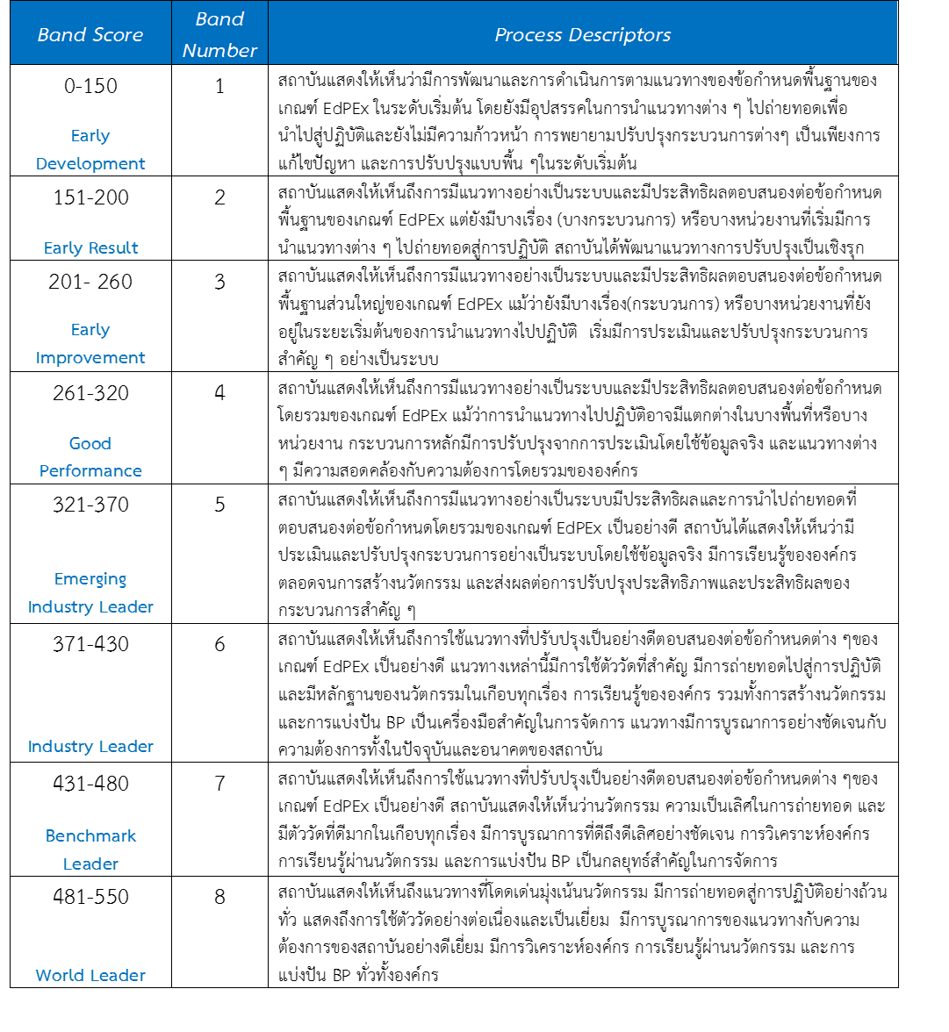

ตาราง 4 คำอธิบายระดับการประเมินในภาพรวมของผลลัพธ์ (Overall Band)

